Approved research grants 2020
In alphabetical order of the main applicant

Research Projects

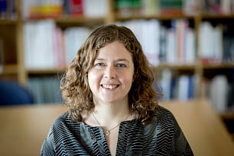 | Elin Bjarnegård  Uppsala University  Project title  Mapping Women Peacemakers: Exploring the ‘More Women-More Peace’ Nexus
Project description

The slogan “More Women – More Peace” draws attention to the lack of gender equality in peacemaking, and suggests that including women will lead to more settlements and more stable post-conflict societies. This conclusion is based on research about the general effects of women’s inclusion in politics and several high-profile examples of activism in countries like Liberia, the Philippines, and Colombia. However, there is a lack of global systematic information and studies about women’s and mens participation in civil war peace processes, as well as on the specific roles they play– as representatives for warring parties, as external mediators, or as third parties representing the domestic civil society or local community.
This project compiles the first global dataset of women peacemakers in civil war 1990-2020, covering both conflicts where peace have been achieved and where it has remained elusive. The data and analysis will be freely available for both scholars and policymakers, and will contribute to improving our possibilities to empirically investigate the various interpretations arising from the proposition that that more women bring more peace.
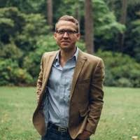 | Travis Curtice  Emory University  Project title  How Coethnic and Gender Biases Affect Citizen-Police Interaction in Fragile and Violent Contexts
Project description

We typically treat law and order as a public good, one provided equally, if not necessarily efficiently, to all citizens. Yet in many fragile and conflict-affected states, policing is viewed and experienced as a private good where citizens are treated unequally based on certain characteristics. We argue that co-ethnicity is one of the most important and persistent identities that shapes citizen attitudes and behavior toward police (and vice versa) in these settings. In particular, we propose to examine how coethnic bias shapes the willingness of individuals to cooperate with police in five countries (Afghanistan, Liberia, Iraq, Uganda, and the United States). We propose a common theoretical and methodological platform that draws on a shared battery of survey experiments to measure civilian attitudes, trust, and behavioral intentions indirectly. We also explore how gender and prior exposure to violence shape citizen-police interactions. We request funding for a pilot study in Afghanistan as a proof of concept for our approach.
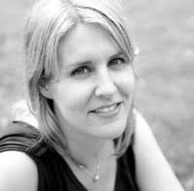 | Kristine Eck  Uppsala University  Project title  Police Oversight in Post-Confllict Security Sector Reform
Project description

How do post-conflict states address police misconduct? Police violence and abuse occurs throughout the world but these problems are particularly acute in post-conflict countries characterized by weak state institutions and legacies of violence. In these environments, police abuse runs a high risk for igniting polarization and violence. International actors have recognized the importance of police reform as part of post-conflict security sector reforms (SSR). One of the ways many states address the problem of police misconduct is with oversight institutions, which facilitate reporting and investigation of misconduct. But there are many different ways these institutions can be designed, and there is no comparative research which addresses the presence or effectiveness of different types of oversight institutions. As a consequence, decisionmakers lack the empirical basis necessary for informed policy. The aim of this project is to map all post-conflict countries to determine if security sector reforms included police oversight mechanisms, as well as the design of the oversight institutions and processes in order to provide an empirical basis for understanding these institutions.
Kristen Kao
University of Gothenburg

Project title
From Revenge to Forgiveness: Strengthening Durable Peace in Post-Conflict Societies
Project description

Civil conflicts gravely damage the state’s legitimacy. Institutions are rendered incapable of providing security; social trust among citizenry diminishes; and non-state actors step in to fill the vacuum of power. After conflict, the state needs to re-establish itself as the legitimate arbiter of processes aimed at bringing former rebel collaborators to justice. Unless it carefully considers subnational variation in the drivers of forgiveness and reconciliation though, the state may generate new grievances among some communities, increasing the chances of civil disobedience or rebel recidivism. This project develops and tests a novel framework integrating political science theories of legitimacy of state and non-state actors with psychological theories of forgiveness, feelings of (in)justice and desire for revenge. To test this framework, we hold in-depth focus groups and implement three large-scale surveys with embedded experiments (N=3,600) in Iraq, a country that has endured a series of civil conflicts culminating in its recent confrontation with the Islamic State (IS). This project employs innovative tools to identify both the subnational drivers of violent resentment and the drivers of reconciliation. It provides policymakers with the information necessary to design successful strategies for reconciliation, re-establishment of state legitimacy, and lasting peace.
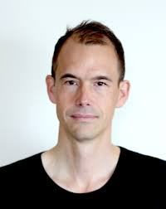 | Magnus Lundgren  Stockholm University  Project title  Terror-listing and Mediation in Armed Conflict
Project description

Over the last decades, states and international organizations have significantly strengthened their ability to provide and support diplomatic conflict resolution, such as mediation. At the same time, they have become increasingly willing to blacklist armed groups, labelling them terrorists and imposing various forms of sanctions. There is a suspicion that these two strategies are conflictual – that terror-listing complicates or crowds out diplomatic conflict resolution – but a lack of data has precluded systematic tests. To enable investigation into how terrorlisting affects mediation, this project will create the first systematic dataset on terror-listed armed actors. The dataset will cover all armed actors in the 1945-2020 period and be constructed to allow easy integration with existing conflict datasets from UCDP, COW, and ACLED. Using the data, the project will examine the impact of terror-listing on mediation in armed conflict. Beyond helping to assess whether terror-listing impacts the scope of mediation, the dataset will be a resource for a number of other research fields, allowing scholars to investigate how the presence of terror-listed armed actors affect conflict resolution, conflict dynamics, and counterterrorism.
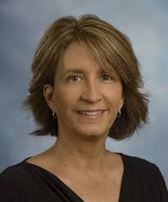 | Carrie Manning  Georgia State University  Project title  Post-conflict statebuilding in comparative perspective: electoral politics, extractive economies, and state consolidation in Mozambique and Angola
Project description

To what degree have the institutions and processes of electoral politics over time helped to build states? This project explores statebuilding through democratization in Mozambique and Angola, in comparative perspective. Apart from adding to our understanding of post-conflict politics in these two important cases, the project offers a fresh perspective on “liberal” statebuilding as a method to achieve durable peace. The project develops a concept of statebuilding as a process of state consolidation through the imposition of electoral politics. State consolidation is the establishment of routines, institutions, and capacities are established that provide the state with broadly accepted authority to make and enforce the law throughout the national territory. Democracy, the dominant post-Cold War approach to internationally-led statebuilding efforts, is the means to this end. It is an effort to achieve peace and to build the foundation for a lasting political settlement without declaring winners and losers. In this regard, democracy’s devices for power alternation and division – elections and decentralized government -- are critical. From this starting point, the project investigates, through longitudinal process-tracing in Angola and Mozambique, the ways in which electoral politics has contributed to or hindered state consolidation.
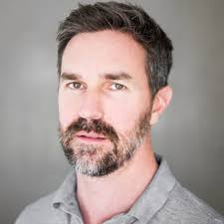 | Jaremey McMullin  University of St Andrews  Project title  Motorcycling as Post-war Reintegration: Assessing Youth Peacebuilding Strategies in Liberia
Project description

How do youth-generated peacebuilding strategies promote reintegration after war? Ex-combatant and conflict-affected youth comprise the vast majority of Liberia’s 175,000 motorcycle taxi drivers. Motorcycling emerged after Liberia’s civil war as a critical economic sector. It provides cyclists with economic livelihood opportunities and constitutes a space of socio-political youth mobilisation. Through motorcycling, youth also establish themselves as active peacebuilding subjects, enacting their own ideas to counter the insecurity and marginalisation of post-war life. The project will evaluate two youth-articulated peacebuilding strategies within the motorcycling sector: provision of educational scholarships to ‘exemplary riders’, and provision of numeracy and business skills training. Multi-sited, ethnographic evaluation, employing participatory action research methods, will gauge the impact of these strategies on livelihood sustainability, educational attainment, and post-war reintegration. The project does not merely explore whether youth strategies succeed, but collates subjects’ narratives, experiences, and perceptions to analyse how and why youth-centred peacebuilding works.
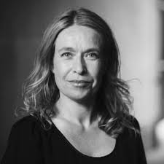 | Desirée Nilsson  Uppsala University  Project title  Civil Society in Peacemaking: Patterns of Civil Society Involvement in the Middle East
Project description

Promoting inclusion of different segments of society is a key priority on the political agenda. The United Nations and the World Bank emphasize that more inclusive processes are vital for peace. One key question when moving from war to peace is who to include in the peace talks. However, we are currently lacking systematic information on different forms of civil society participation during peace processes. This project seeks to expand an existing data collection on civil society involvement covering Africa and Americas to also encompass the Middle East. In order to better understand patterns of peacemaking in armed conflicts in the Middle East – which includes contemporary civil wars such as Iraq, Israel-Palestine, Syria, and Yemen – it is of critical importance that we collect systematic information about how civil society actors have been engaged. The data collection includes information on the type of actors involved, as well as their roles during this process, for example, attendance at the formal negotiations, but also participation by civil society through for instance parallel negotiation forums, or mass demonstrations. This will for example allow us to explore why some peace process are more inclusive than others, and how different forms of civil society participation – both inside and outside of the formal peace negotiations – can help sustain peace.
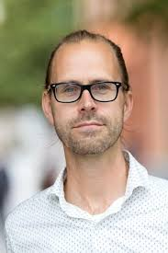 | Isak Svensson  Uppsala University  Project title  Nordic experiences of mediation: exploring the role of mandates in mediation processes
Project description

Civil war is a dynamic process of repeated violent and cooperative interactions between combatants. Existing research, however, focuses almost exclusively on violence, paying little attention to cooperation (e.g. ceasefires, negotiations) during conflict. To understand how cooperation affects conflict dynamics and settlement, this project addresses two key research questions: First, does the outcome of past cooperation influence future cooperation and conflict between combatants? Second, how does the history of cooperative attempts between combatants shape the eventual terms of settlement and prospects for sustainable peace? We propose to collect novel data on the content and outcome of negotiations during civil wars as a first step to assess the question of how cooperation affects the conduct and settlement of civil conflicts. By focusing on negotiations as an iterative learning process, this project (1) challenges the dominant approach in civil conflict research, which often ignores cooperation that occurs during conflict, and (2) uniquely accounts for how past negotiations influence future interactions as combatants learn, rather than treating negotiations as isolated events.
Michael Weintraub
Universidad de los Andes

Project title
The Microfoundations of DDRR: A Panel Survey of FARC Ex-Combatants in Colombia
Project description

After more than fifty years of civil conflict, Colombia faces a unique opportunity to consolidate a still-fragile peace. A core obstacle to the successful implementation of the peace agreement signed between the Colombian government and the FARC-EP in 2016, remains the effective reincorporation of ex-combatants into civilian life. In this project, we develop and implement an unprecedented monitoring system of recently-demobilized FARC combatants via quantitative panel surveys, a series of behavioral games, and focus groups. With a significant sample of approximately 4,000 ex-combatants, ours constitutes an ambitious effort to collect systematic data about ex-combatants and their ongoing processes of reincorporation in real time. The project makes a twofold contribution. First, it contributes to the academic literature on civil conflict and peacebuilding by providing evidence about the microfoundations underpinning prominent macro-level theories. Second, it generates fundamental public policy recommendations regarding the implementation of reincorporation strategies and the design of durable peace agreements in Colombia and other countries affected by civil conflicts.

Research Workshops

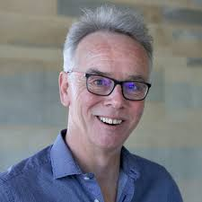 | Han Dorussen  University of Essex  Project title  Workshop on Peacekeeping and International Relations
Project description

The proposed workshop will bring together contributors to the Handbook on Peacekeeping and International Relations to be published by Edward Elgar Publishers in 2021 and edited by Han Dorussen. The Handbook aims to provide an overview of these recent developments in the peacekeeping literature and to highlight key theoretical insights and main empirical findings. The Handbook, moreover, will reflect important methodological developments. The study of peacekeeping has become more and more comparative in nature. Researchers have collated new and more detailed data on peacekeeping, and have begun to apply geospatial models and event analysis. The Handbook will thus provide an overview of the state of the art in the study of peacekeeping and international relations and calibrate the scope of research in the field. The workshop will take place in the Netherlands (Amsterdam or the Hague) in Autumn 2020 and provides an opportunity for contributors to receive feedback on their draft chapters. Further, the workshop will be organized in collaboration with the recently established Dutch Network on Peace Operations which brings together academics, policymakers, NGOs and other parties who are involved in peace operations in the Netherlands. Thus, it will provide an opportunity for intellectual exchange with the wider Network.
Caroline Hartzell
Gettysburg College

Project title
Workshop on Research on Citizens in Peace Processes: Addressing Common Challenges, Shaping a Joint Research Agenda
Project description

A growing number of scholars is engaging in microlevel research – surveys, experiments, focus groups – in an effort to identify the roles citizens play in peace processes and the factors that shape their commitment to the peace. Although some of the scholars engaged in this research are familiar with one another’s work, this research can largely be characterized as taking place in disconnected silos. Accordingly, the purpose of this workshop is to bring together scholars to identify and address common challenges they grapple with in this area of research and to shape a forward-looking research agenda on citizens in peace processes.

The workshop will address central issues that influence research questions and research design with regard to the roles of citizens in peace processes; means of contending with methodological, epistemological, ethical, and financial challenges encountered in microlevel research on citizens in peace processes; and how scholars can best engage with interested policymakers. We will address these issues by drawing on the experiences of individuals currently engaged in research on citizens in peace process, as well as with scholars and scholar-practitioners with expertise of direct relevance for the citizens in peace process agenda, including conflict-induced psychological trauma, and ongoing citizen engagement in the humanitarian and development fields.

